**Divisible by 5 and 11**

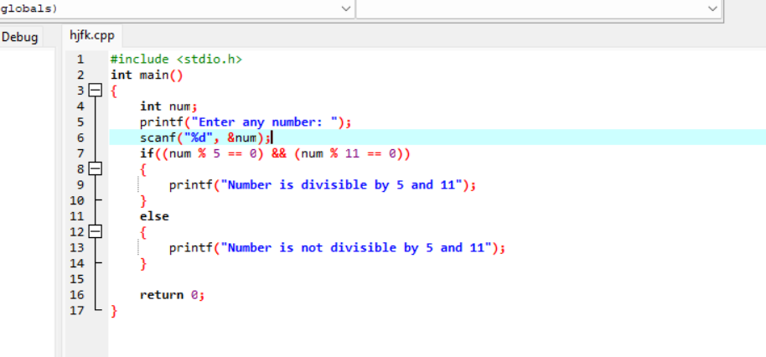

**Output**

